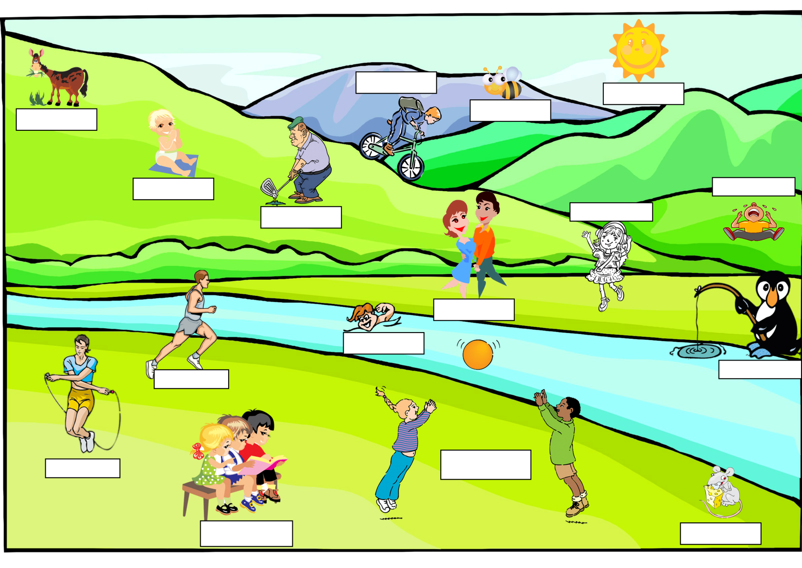

1. Write the names to the people and things in the picture:
Charlie is sitting on the ground. The Penguin is fishing. James is running. Martha and Joe are playing with a ball. Carl, Jane and Paul are reading a book. The sun is shining. The bee is flying. Alex is swimming. Cameron is playing golf. Sarah is skipping the rope. The horse is eating grass. Michael is riding a bike. David is crying. Nick and Sue are dancing. The mouse is eating cheese. Emma is listening to music.
2. Cover the exercise 1 and complete the text:
Charlie__________sitting on the ground. The Penguin__________fishing. James__________running. Martha and Joe__________playing with a ball. Carl, Jane and Paul__________reading a book. The sun__________shining. The bee__________flying. Alex__________swimming. Cameron__________playing golf. Sarah__________skipping the rope. The horse__________eating grass. Michael__________riding a bike. David__________crying. Nick and Sue__________dancing. The mouse__________eating cheese. Emma__________listening to music.
3. Cover the exercises above and complete the text:
Charlie ______________ (sit) on the ground. The penguin ______________ (fish). James ______________(run). Martha and Joe ______________ (play) with a ball. Carl, Jane and Paul ______________ (read) a book. The sun ______________(shine). The bee ______________ (fly). Alex ______________(swim). Cameron ______________ (play) golf. Sarah ______________ (skip) the rope. The horse ______________ (eat) grass. Michael ______________ (ride) a bike. David ______________ (cry) . Nick and Sue ______________ (dance). The mouse ______________ (eat) cheese. Emma ______________ (listen) to music.
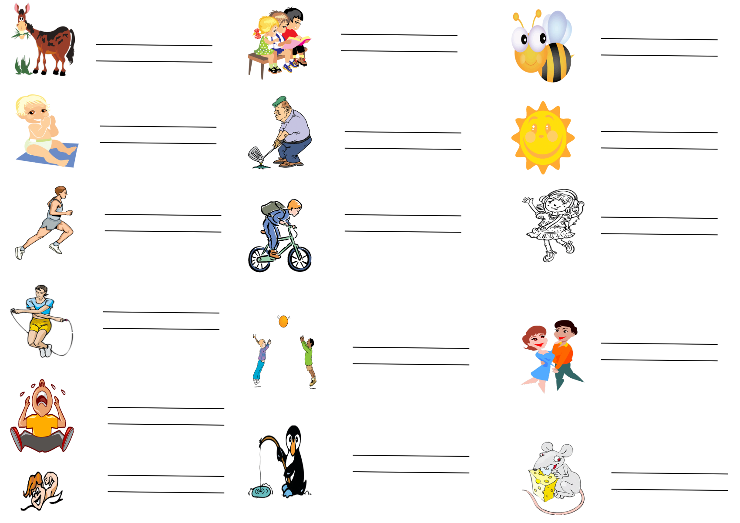
4. What they doing:

5. Write what the people doing in these situations.
1. I am in front of the television. I _________________ it.
2. James has opened a packet of crisps. Now he ______________________ them.
3. Sue has got a cup of tea in her hand. She _______________________ it.
4. Mr Brown has got a book in his hands. It is open. ___________________________ it.
5. You in a supermarket. You ___________________________.
6. Mike is in the bathroom. _________________________ a shower.
7. I am in my bed. It is late at night. ___________________________________.
8. Jane has got an important exam tomorrow. She _______________________ for the exam.

