Placement test
We don't _____ lunch at school.

( ) | have
( ) | stand
( ) | eats
( ) | sit
My first name is Ella and my ____ is Johnson.

( ) | surname
( ) | how
( ) | like
( ) | am
What is in the picture? |  | 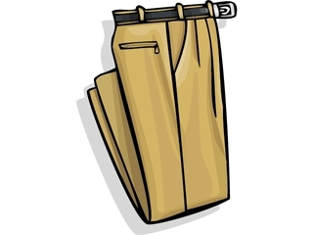
( ) | Trousers
( ) | A skirt
( ) | Shoes
( ) | A hat
What is this?

( ) | A bookcase
( ) | A carpet
( ) | A rug
( ) | A cupboard
She ____ ski.

( ) | can
( ) | is
( ) | has
( ) | have
The rabbit is ____ the box. |  |  | 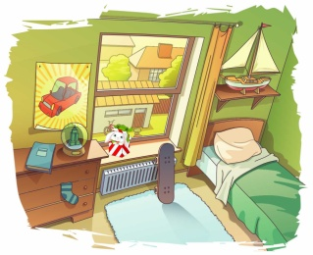
( ) | in
( ) | under
( ) | between
( ) | behind

____ old are you?

( ) | When
( ) | How
( ) | Why
( ) | Whose

I have got two _____.

( ) | box
( ) | boxes
( ) | boxs
( ) | boxis
We ____ got any money.

( ) | has
( ) | haven't
( ) | havn't
( ) | hasn't

She is ___ the USA.

( ) | from
( ) | at
( ) | of
( ) | on
See _____ later.

( ) | you
( ) | she
( ) | me
( ) | they
______ a car? Yes, I have.

( ) | Have you got
( ) | She has got
( ) | You have got
( ) | Have you
______ any shops in your street? Yes, there are.

( ) | Are there
( ) | There are
( ) | Are
( ) | Is there
He ____ football on Mondays.

( ) | plays
( ) | go
( ) | play
( ) | goes
It's _____ orange.

( ) | a
( ) | white
( ) | an
( ) | has

We ______ from New York.

( ) | isn't
( ) | aren't
( ) | am
( ) | is
It 5:45. It is ______ six.

( ) | quarter to
( ) | quarter past
( ) | fifteen past
( ) | half past
She is my mother's mother. She is my _____.

( ) | grandmother
( ) | father
( ) | sister
( ) | nephew
Hi Amy. How ____ you?

( ) | is
( ) | are
( ) | be
( ) | am
Paris ___ in France.

( ) | are
( ) | is
( ) | be
( ) | am
What is this school subject? |  |  |  | 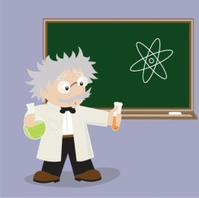
( ) | Science
( ) | English
( ) | Maths
( ) | PE
_____ is after Thursday.

( ) | Friday
( ) | Sunday
( ) | Monday
( ) | Saturday
She ______ a book now.

( ) | is reading
( ) | are reading
( ) | reading is
( ) | reading
She ___ got a camera.

( ) | has
( ) | are
( ) | is
( ) | have
The book is ____ the poster.

( ) | under
( ) | behind
( ) | in
( ) | on
I've got ________.

( ) | black dogs two
( ) | two black dogs
( ) | two dogs black
( ) | dogs two black
There are three ____.

( ) | man
( ) | childs
( ) | woman
( ) | men
I ____ at school today.

( ) | is
( ) | amn't
( ) | aren't
( ) | am not
______ does she have dinner? At six o'clock.

( ) | When
( ) | Why
( ) | Where
( ) | Who
11 = ______

( ) | twelve
( ) | twenty
( ) | eleven
( ) | fifteen
_________ TV every day? Yes, she does.

( ) | Does she watch
( ) | She watches
( ) | Watches she
( ) | Do she watch
He is my father's son. He is my ______.

( ) | brother
( ) | father
( ) | sister
( ) | cousin
There are four _____ in the street.

( ) | people
( ) | person
( ) | childrens
( ) | mens
_____ raining?

( ) | Is
( ) | Is there
( ) | Are
( ) | Is it
When ___ his birthday?

( ) | is
( ) | be
( ) | am
( ) | are
What is in the picture? |  | 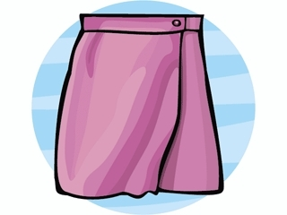
( ) | a T-shirt
( ) | A cap
( ) | A skirt
( ) | A jumper
We ____ speak English.

( ) | can
( ) | has
( ) | are
( ) | cans
_____ two bedrooms in our house.

( ) | There are
( ) | It are
( ) | Are
( ) | There
_______ ride a horse?

( ) | Can he
( ) | He can
( ) | He
( ) | Cans he
I _____ up at six o'clock in the morning.

( ) | get
( ) | sit
( ) | brush
( ) | go

